**Persona:**

**Name:** Sieuwerd H. De Bruin

**Occupation:** High School Student

**Demographics:**

16y/o, he/him

Netherlands

Single

Mother, Father, younger sister

**Goals:** To be popular, and show off his high-level skills

Spend more time with his sister

Graduate High School, attend a good, local Trade School, or Community College to become a civil engineer

**Pain Points:** Card games have become too easy for him. Does not like long queue time for online card games. Not getting worthy players from online, they take too long to make moves.

**Behavior:** Usually spends more of his time on his phone. Does not hang out with people from school, most of the time by himself.

**Personality:** Introvert, likes to escape from the world into his phone



**MoodBoard:**

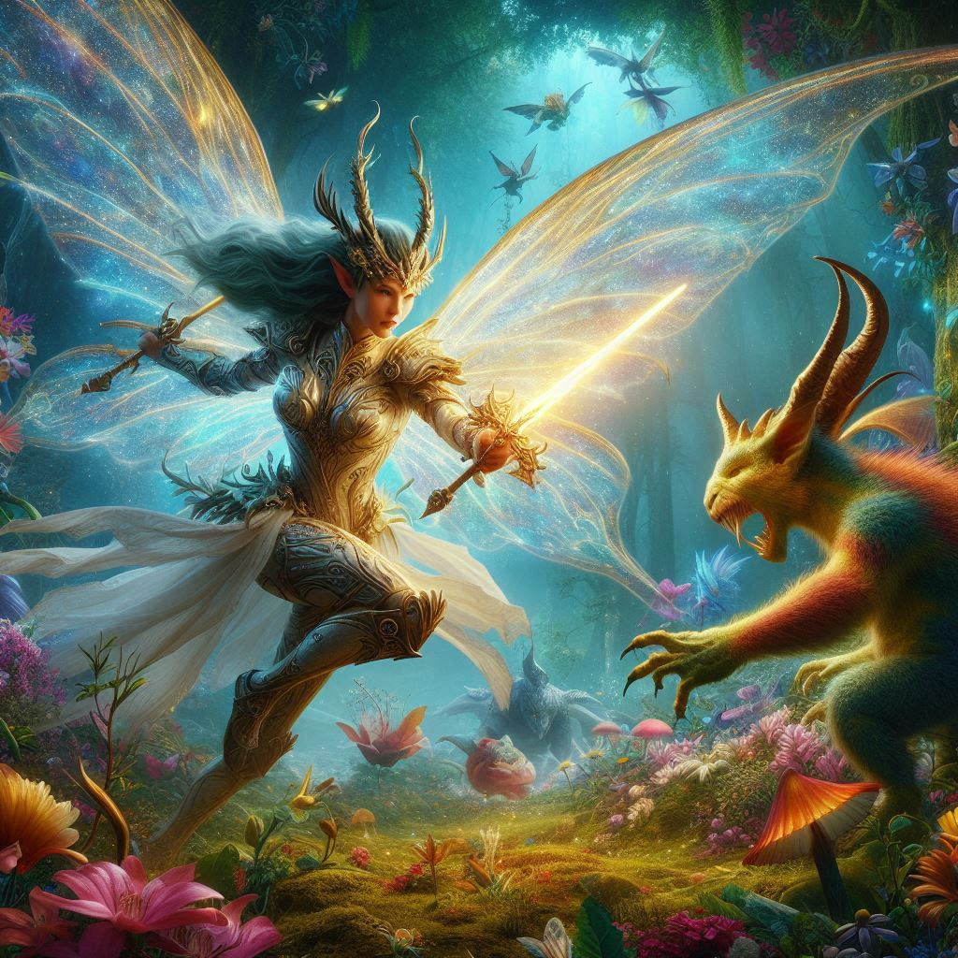

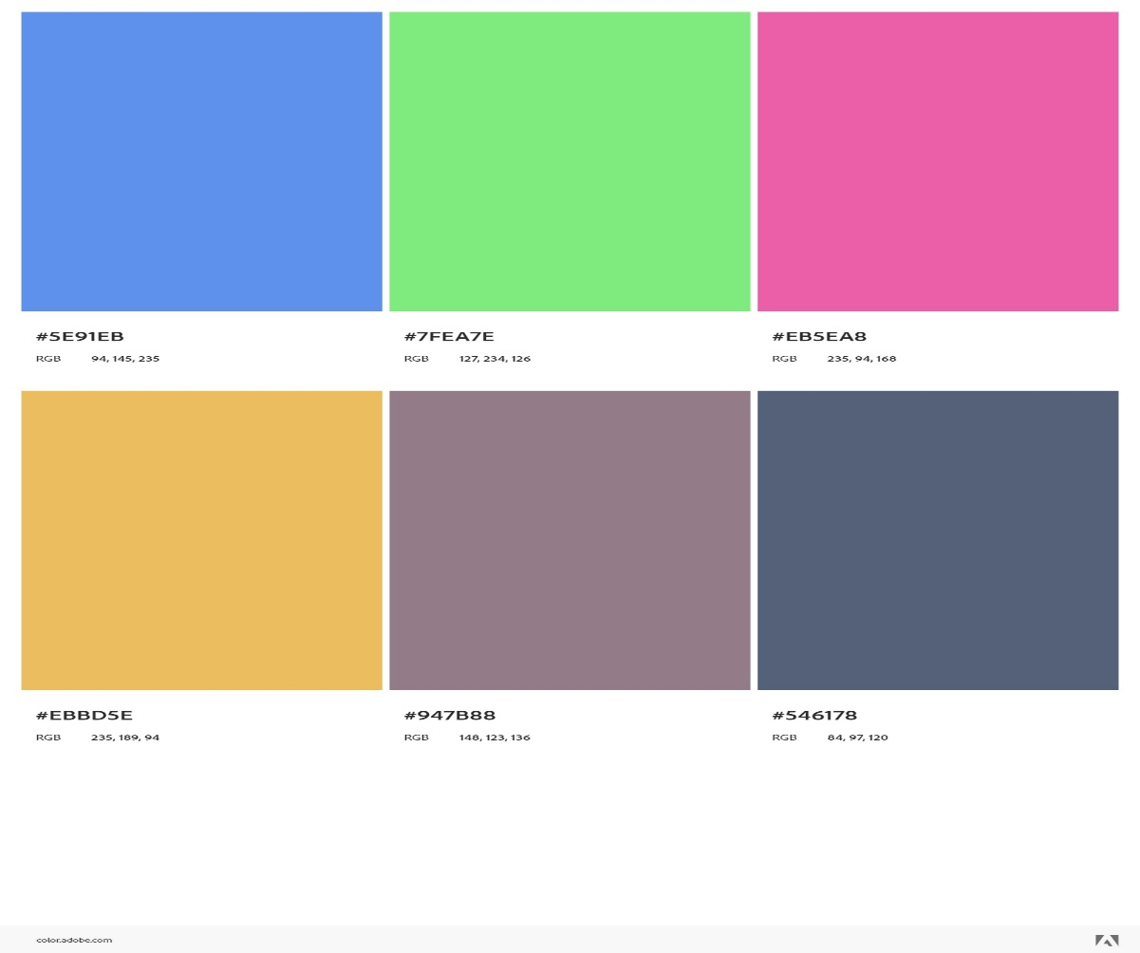

**“**This reminds me of my childhood”

“Playing the game feeling like being in an action movie”

Text Font:

* MoolBoran
* Ink Free
* Rockwell

**Pattern:**



**Texture:**



**Logo Inspo:**

